Step 16. Save Machine File
In this section, you will save the machine file which contains all of the measure up and calibration data that has been generated in previous steps.
Note: It is best practice to save settings after the validation has occurred. This creates a record of the configuration that can be re-loaded in the future should issues occur.

1. Navigate to the Advanced menu and enter the Machine Settings Files screen
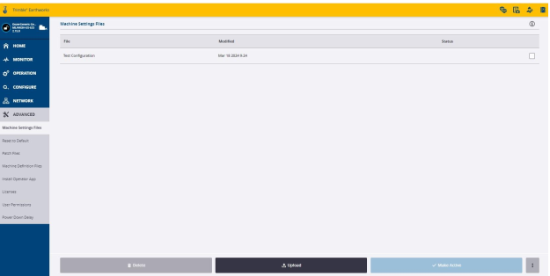
2. Select the hamburger menu at the bottom right corner and select Save Settings.
3. Name your Machine Settings File and select Save.
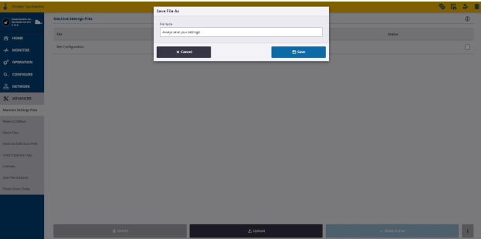
4. The newly saved .machine file will now show within the list. It will also show as
“Last Activated” under the Status bar showing it is currently loaded and active in
the system.
Note: It is possible to download the .Machine file from this screen to store it for reference should it be needed in the future.

